Ch 22.3 Notes

---------------------------------------------------------------------------------------------------------------------

Vocab

---------------------------------------------------------------------------------------------------------------------

Homology: Similarity resulting from common ancestry

Homologous Structures: Represent variations on a structural theme that was present in their common ancestor

Vestigial Structures: Remnants of features that served a function in the organism’s ancestors

Evolutionary Tree: A diagram that reflects evolutionary relationships among groups of organisms

Convergent Evolution: The independent evolution of similar features in different lineages

Analogous: Examples in which species share features because of convergent evolution

Biogeography: The scientific study of the geographic distributions of species

Endemic: A species found no where else in the world

---------------------------------------------------------------------------------------------------------------------

Notes

---------------------------------------------------------------------------------------------------------------------

Homologous structures

* + Similar structure, different function.
  + Closely related genetically= recent common ancestor

Analogous structures

* + Different structure, similar function.
  + Not closely related genetically= distant common ancestor
  + Common pressures (similar environment maybe)
    - Convergent evolution

Structures that are inherited from ancestors but don’t serve original function

Why still exist then?

* + Not really getting in the way, not any pressure to select against them?

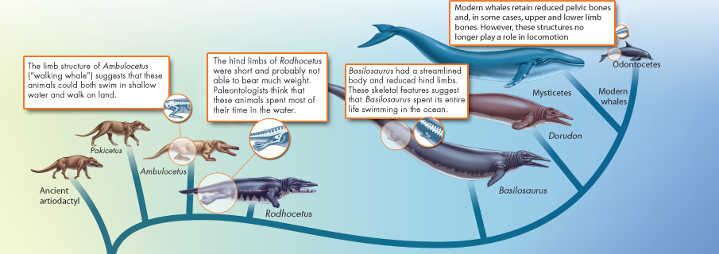 Patterns in the distribution of fossils and geography can tell us how modern organisms evolved from their ancestors

* + Closely related species can evolve different adaptations in different environments
  + Distantly related species can evolve similar adaptations if they live in similar environments (or face similar environmental pressures)
* Galapagos finches may have evolved from mainland species
* Natural selection produced variation among populations

Embryology = Similarities in development suggest common ancestry

Darwin didn’t know how heredity worked

* + Now, comparing DNA sequences is one of the strongest pieces of evidence to show how closely (or distantly) related organisms are

ALL living things have a genetic code

All living cells use DNA to produce protein and pass information to offspring

* + Suggests all living things that use DNA come from a common ancestor

Genetic code is almost identical in all living things

**If evolution did not occur, then all living things would have to develop DNA independently.**

Proteins used in common functions suggest common ancestry

* + Yeast cell respiration and human cell respiration use the same proteins

*Hox* genes determine head-to-tail structure of multicellular organisms

* + Small changes in genes can lead to big changes in development

Evolution is difficult to observe, because it usually takes millions of years to occur

In a lab, experiments have demonstrated evolution in many organisms, including bacteria, guppies, and fruit flies… but what about in nature?

Drs. Peter and Rosemary Grant of Princeton University picked up where Darwin left off

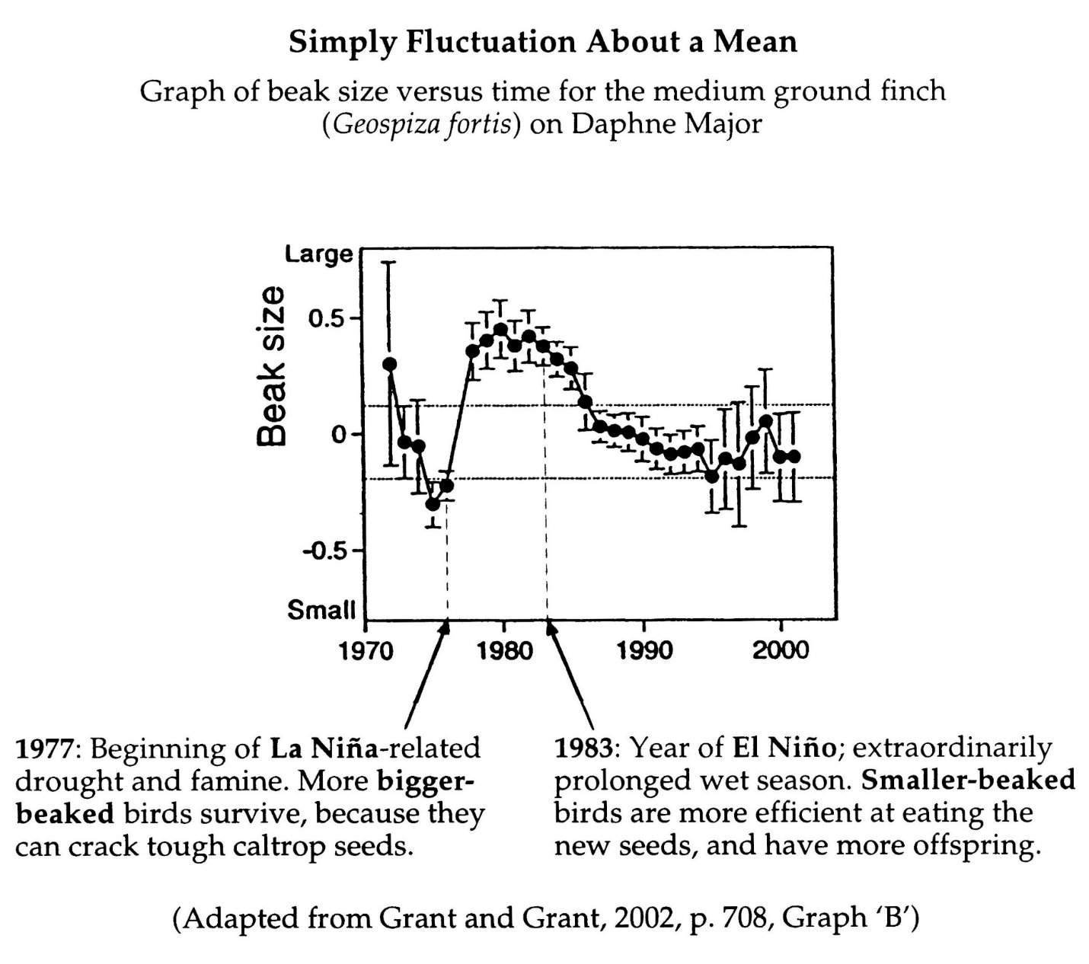

Theory is constantly reviewed and updated as new data is gathered

Questions remain about **how** evolution works, but not **whether** evolution occurs

* + Still debate about details of how new species arise and why some become extinct
  + Still debate about how life began